DETECTING STREET SIGNS FOR VISUALLY IMPAIRED PEOPLE: A YOLOv8 AND FEDERATED LEARNING-BASED APPROACH
Merve Sinem Karahan , Mehmet Karaköse ²
^{1,2} Computer Engineering, Engineering Faculty, Fırat University, Elazığ, Türkiye.
¹msinemkarahan@gmail.com, ² mkarakose@firat.edu.tr

¹(ORCID: 0009-0003-3960-6616), ²(ORCID: 0000-0002-3276-3788)

Abstract
In this thesis study, an artificial intelligence-based system has been developed to support visually impaired individuals in navigating urban environments by enabling real-time detection of street signs. The system is built on the integration of the YOLOv8 object detection model and a federated learning architecture. This approach allows training to be performed locally on user devices without transferring any personal data to a central server, ensuring data privacy while enabling continuous model improvement through distributed learning. The system was tested in a federated learning scenario involving five clients. Each client was modeled with non-IID data structures containing various types of signs such as traffic, direction, restaurant, and pedestrian crossing signs. The learning performance of the system under this heterogeneous data distribution was thoroughly evaluated. At the end of the training process, the YOLOv8 model trained via federated learning achieved an accuracy of approximately 88%. Additionally, the model’s performance was assessed using precision, recall, and F1-score metrics. The accuracy of the system was validated not only through numerical metrics but also via real-time computer vision outputs. A model deployed through an OpenCV-based camera application successfully detected different types of signs with high accuracy, providing visual feedback to the user. A performance comparison between centralized and federated scenarios further demonstrated that federated learning can achieve competitive accuracy even in distributed settings.
In conclusion, this thesis demonstrates that object detection systems built with federated learning architectures can be effectively applied in real-world scenarios, particularly contributing to privacy, scalability, and real-time deployment in assistive technologies.
Keywords: federated learning, YOLOv8, visually impaired, object detection, traffic sign recognition, real-time image processing, privacy-preserving AI

1. Introduction

With the advancement of smart city technologies, the need for real-time data processing and object recognition systems is increasingly growing. In this context, the rapid and secure operation of visual perception systems holds significant importance for urban transportation safety. However, centralized data collection methods used in such systems can lead to issues such as privacy violations and high bandwidth consumption. The Federated Learning (FL) approach offers a solution to these challenges by enabling data to be processed on local devices, allowing artificial intelligence models to be trained without the need for a central server. In this thesis study, a novel traffic sign detection simulation has been developed and tested by integrating a YOLO-based object recognition algorithm with an FL architecture. This real-time simulation is designed to visualize the practical applications of federated systems and to evaluate the effectiveness of the model.
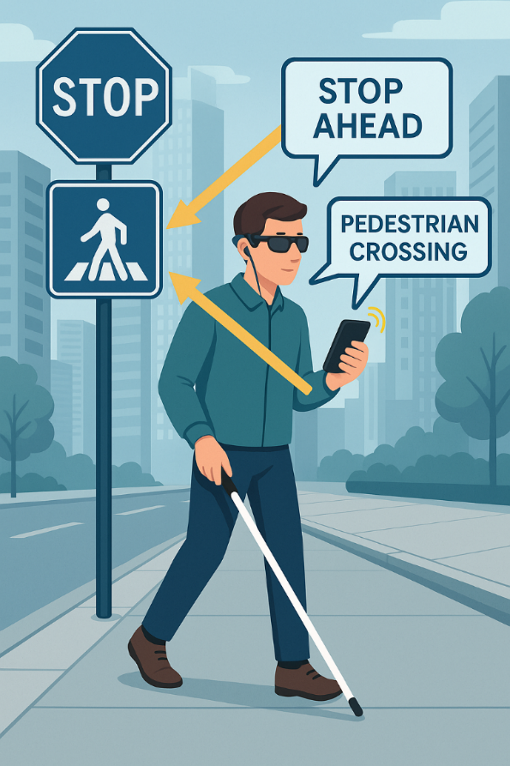

Figure 1. Scenario diagram showing the project working at the user level

As illustrated in Figure 1, the scenario represents a visually impaired individual receiving audio guidance via a mobile device by detecting surrounding street signs. The system employs a YOLOv8 model trained using a federated learning architecture to identify traffic signs such as “STOP” and “PEDESTRIAN CROSSING.” It provides real-time audio alerts to the user. This approach not only enhances user safety but also contributes to independent mobility.

2.Comparative Review of Related Literature
In recent years, significant advancements have been made in deep learning-based computer vision and distributed learning systems. This section provides a comparative overview of recent studies focusing on object detection (YOLO architecture), federated learning security structures, scene text recognition (OCR), low-light image enhancement, and alternative deep learning solutions—examined in terms of architectural structures, application scenarios, advantages, and limitations.
The following rules should be followed for the page layout. This document is recommended as the template for the articles to be submitted according to the required conditions.
2.1. YOLO-Based Object Detection Models
Among single-stage object detection models, the YOLO architecture stands out with its speed and real-time processing capabilities. Terven and Cordova-Esparza (2023) [1] provided a comprehensive review of the evolution from YOLOv1 to YOLO-NAS, systematically analyzing the architectural changes in backbone (feature extraction), neck (feature fusion), and head (prediction) layers. The shift of YOLO models toward anchor-free designs and the integration of attention mechanisms have significantly improved the balance between accuracy and performance. Various studies have demonstrated the adaptability of YOLO models across domains, particularly in small object detection [7, 24], low-light conditions [9], agriculture [8], security [16], and IoT applications [10]. For instance, YOLO-BS, proposed by Zhang et al. [7], incorporates BiFPN and customized small-object layers, achieving successful detection even in complex backgrounds. Similarly, Zhou et al. [9] significantly enhanced object detection in low-light environments using deformable convolutions and BiFormerBlock modules in the DBS-YOLOv8 model. In agricultural contexts, Tran and Pham [8] showed that YOLO outperforms SSD MobileNet in both accuracy and speed. This diversity highlights YOLO’s strong compatibility for domain adaptation.
2.2. Federated Learning and Security Approaches
Growing concerns over data privacy have increased the importance of federated learning (FL) architectures. However, these systems face notable challenges related to security vulnerabilities, privacy leakage, and threats to centralized structures. Jie Fu et al. (2024) [2] systematically explored the integration of differential privacy (DP) models into FL systems, addressing the roles and limitations of central DP, local DP (LDP), and mix-based systems in both horizontal and vertical FL scenarios. While the move toward decentralized structures enhances scalability, it also introduces new security threats. Hallaji et al. (2024) [3] analyzed issues such as data manipulation, malicious client attacks, and validation challenges in blockchain-based decentralized FL systems, offering suggestions for secure parameter sharing. Furthermore, Zhang et al. (2023) [14] examined the threats encountered in FL applications involving medical data, emphasizing privacy and model integrity. In this context, hybridizing FL with differential privacy and blockchain technologies may form the foundation for next-generation secure learning systems.
2.3. Visual Text Recognition (OCR) and Linguistic Analysis
Text recognition in visual environments is a critical area for both accessibility and semantic analysis. Khan et al. (2021) [12] categorized deep learning models used in scene text recognition, evaluating the advantages and limitations of regression-based, segmentation-based, and hybrid approaches. The shift from traditional methods to deep learning models has led to performance improvements, particularly in handling font variability and background complexity. A system proposed by Kim et al. (2025) [11] enabled the semantic mapping of street-level language distribution, significantly contributing to the integration of OCR with geographical and cultural analysis. This has important implications for urban planning and cultural mapping. Additionally, comprehensive surveys such as the one by Naosekpam and Sahu (2022) [27] benchmarked the accuracy and speed of existing methods using standard datasets, clarifying which issues new methodologies should address. Thus, OCR models are increasingly applied not only to character recognition but also to semantic context and environmental impact analysis.
2.4. Low-Light Image Enhancement
Processing images under low-light conditions is critical for improving visual clarity in applications such as security, autonomous vehicles, and mobile devices. Liu et al. (2024) [35], through an in-depth analysis of NTIRE competition solutions, investigated the contributions of channel attention mechanisms, residual learning, and adaptive enhancement modules to LLIE performance. Their study demonstrated that deep convolutional network structures significantly outperform traditional techniques. Nahari et al. (2020) [37] proposed an AI-based contrast optimization approach for detail recovery in underexposed images, going beyond classical histogram equalization. Wu et al. (2023) [38] introduced a novel approach by leveraging scene-specific semantic guidance to optimize brightness and color balance in LLIE applications. The success of these models also necessitates the development of new metrics for assessing enhancement quality on real-world images.
2.5. Alternative Deep Learning Approaches
In addition to YOLO, other deep learning models continue to be applied across various problem domains. EfficientDet [41] provides suitability for low-power devices due to its smaller model size and optimized inference time, while loss functions such as MPDIoU [40] enable more accurate localization for small objects. HDRNet [33] demonstrated the contribution of channel attention mechanisms to HDR generation, yielding significant improvements in brightness and edge details. Furthermore, traditional algorithms like the color- and shape-based traffic sign recognition method developed by Le et al. [17] remain viable in scenarios with limited computational resources. As such, the hybridization of modern AI models with classical techniques may open new avenues for practical, resource-aware solutions.

Table 1. Literature Summary
Author(s) | Study Title | Method | Technical Features | Contribution
Terven & Cordova-Esparza [1] | Comparative Analysis from YOLOv1 to YOLO-NAS | YOLO Architectures | Convolutional architectural evolution, anchor-free designs | Comparison of accuracy and speed throughout YOLO evolution
Jie Fu et al. [2] | Differential Privacy in Federated Learning (DP-FL) | DP-FL | Central/Local DP, transfer FL, mixing-based model | Analysis of privacy-accuracy trade-offs
Zhou et al. [9] | DBS-YOLOv8: Enhanced YOLOv8 for Low-Light Conditions | YOLOv8 + Deformable Convolution + BiFormer | Low-light dataset and BiFPN integration | High accuracy and superior low-light performance
Khan et al. [12] | Deep Learning-Based Scene Text Detection | DL-based OCR | Regression, segmentation, and hybrid models | Advantages and limitations of each OCR approach
Hallaji et al. [3] | Blockchain-Based Security in Decentralized FL | DFL (Decentralized Federated Learning) | Vulnerabilities and defense mechanisms | Model security in decentralized FL systems
Meng & Shi [24] | Small Traffic Sign Detection Using YOLOv7 | YOLOv7 + SPPFCSPC + S-CARAFE | Feature enhancement and re-sampling modules | Improved accuracy in small object detection

The literature summary table presented above offers a comparative evaluation of recent and high-impact studies conducted across various thematic domains. The works are grouped into a wide technical spectrum, including the evolution of YOLO architectures, privacy and security approaches in federated learning systems, scene text recognition (OCR), low-light image enhancement, and alternative deep learning methodologies. Each study has been carefully selected based on the model or method employed, its technical innovation, and its contribution to the field. This table not only summarizes key advancements in the literature but also provides a comprehensive perspective on the strengths and application potential of the reviewed methods. In doing so, it supports the theoretical foundation of the system proposed in this thesis.

3. Method and Application

During the implementation phase, a client–server structure was simulated to test how the model operates within a distributed learning environment. Additionally, a real-time traffic sign detection scenario was constructed to evaluate the system’s performance. The software libraries used, data flow architecture, and model update processes were explained step by step.
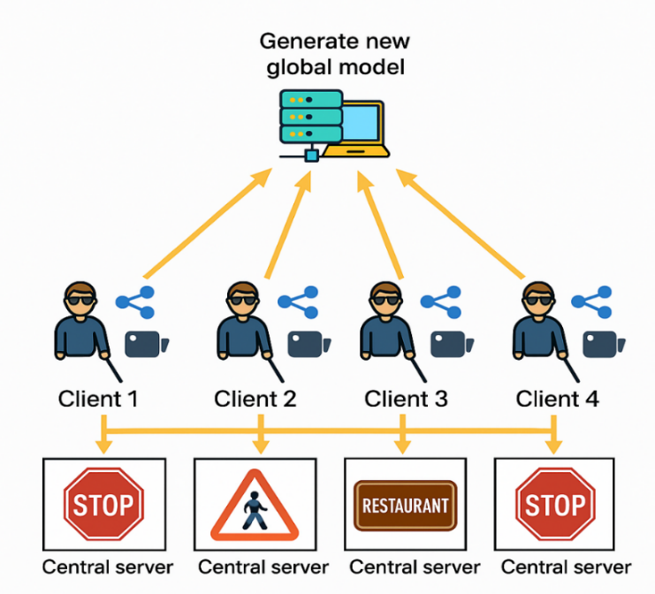

Figure 3. General architecture of the Federated Learning based sign detection system

In this study, a smart sign recognition architecture based on federated learning has been developed to address the needs of visually impaired individuals in urban environments—specifically for navigation, reading signage, and enhancing environmental awareness. The system architecture consists of four main components: client devices (smart glasses or mobile devices equipped with camera hardware), a YOLOv8-based object detection module, an OCR (optical character recognition) component, and a central server (responsible for server-side federated aggregation). On the client side, the camera module used by the visually impaired individual captures real-time images from the environment. These images are processed by a lightweight YOLOv8 model running locally on the device to detect traffic and directional signs. To ensure compatibility with low-power devices, the Nano or Small variants of YOLOv8 are utilized. The detected regions are then analyzed by an OCR engine (e.g., Tesseract or EasyOCR) to extract the textual information from the signs. Models trained locally on the client devices transmit only the model weights to the central server—without sharing any raw data. The server aggregates these weights using the Federated Averaging (FedAvg) algorithm to update the global model. In this way, each client contributes to the overall system performance while preserving data privacy. The updated global model is then sent back to the clients, enabling continuous, cyclical improvement of the system.A key feature of this architecture is its robustness to non-IID (non-independent and identically distributed) data conditions. For instance, one client may frequently encounter signs such as “RESTAURANT” and “MARKET,” while another may primarily detect “STOP” and “PEDESTRIAN CROSSING” signs. This diversity does not harm the global model thanks to the adaptive nature of the federated learning architecture. From a hardware perspective, the system operates between edge devices (such as Raspberry Pi, Android smartphones, or smart glasses) and a cloud or local server. The system can also be configured to run entirely offline, requiring connectivity only during model update phases. This feature enables uninterrupted service for visually impaired users, even under varying network conditions.

3.2 Preparation of the Data Set
In this study, the dataset underwent fundamental preprocessing steps including normalization, resizing, and label transformation. All data were structured in accordance with the requirements of the YOLOv8 architecture. Following these steps, the model training process was initiated. For use within the federated learning framework, a custom dataset consisting of 2,000 labeled street sign images was created. The labeled data were balanced to represent various types of street signs (e.g., stop signs, speed limits, directional signs). As the distributed learning setup involved 5 clients, each client received approximately 400 samples. However, this sample size per client was insufficient in terms of class diversity and overall model performance.
To address this limitation and enhance the representational capacity of each client, targeted data augmentation strategies were applied. During augmentation, class distributions were analyzed, and underrepresented classes were prioritized. Techniques such as flipping, rotation, random zooming, and color jittering were applied to these selected samples. This approach preserved the inter-client distribution while reducing class imbalance and improving the model’s generalization capability. For the implementation of the federated learning architecture, the open-source Flower (FL) framework was utilized. This framework allows each client to perform local model updates, after which the central server aggregates the weights using the Federated Averaging (FedAvg) algorithm to update the global model.
As a result, a balanced and effective data distribution was achieved in a resource-constrained, labeled data setting. The constructed dataset and augmentation pipeline provided a suitable foundation for successful client-based learning within the federated learning paradigm.
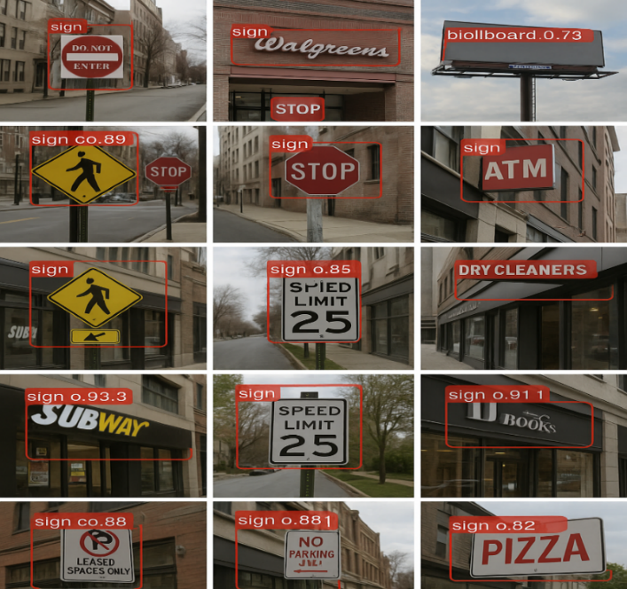
Figure 3.2. Detection of various street signs and confidence scores with the YOLOv8 model

Figure 3.2 illustrates various street signs detected by the YOLOv8 model. The model successfully identified signs with different contents with a confidence interval ranging from 73% to 93%, and all detections were labeled under the “sign” class. The images demonstrate that the model operates with high accuracy in real-world scenarios, providing technical evidence of its effectiveness.
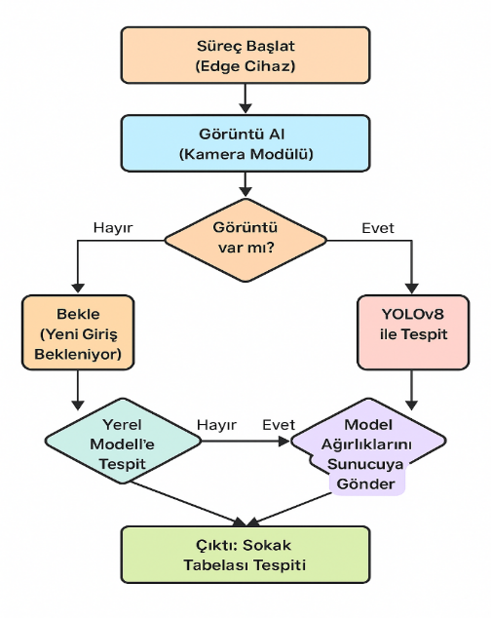
Figure 3.3. Process flow diagram of the proposed system

Figure 3.3 presents the decision-based flow diagram of the developed system. The process begins with the system being initialized on the edge device. In the first step, the camera module captures images from the surrounding environment. The system evaluates the validity of the acquired image; if no meaningful input is detected, it transitions into a passive state and awaits new input. If a valid image is obtained, the YOLOv8 object detection model is activated to identify objects within the input data. At this stage, the system checks whether the federated learning (FL) framework is active. If FL is not enabled, the output is processed and classified using the local model only. However, if FL is active, the locally trained weights are transmitted to the central server, where they are integrated with the global model. Ultimately, the system produces an output in which street signs are accurately classified. This architecture enables end-to-end learning while preserving data privacy and leveraging the advantages of distributed systems.

3.4 Model Training and Federated Learning Structure
In this section, the Federated Learning (FL) approach employed in the proposed system is elaborated. The processes of training and updating the model without sharing raw data among clients are described in detail. The diagram below illustrates the fundamental operational steps of the FL cycle.

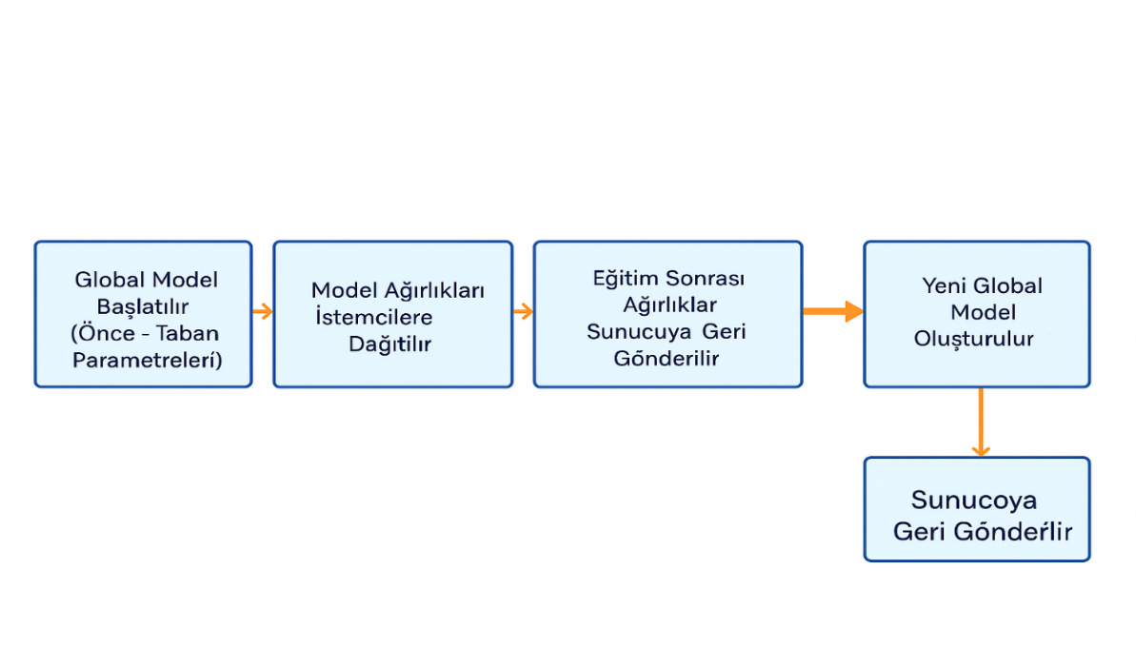
Figure 3.4. General structure of the Federated Learning process cycle

Figure 3.4 illustrates the four fundamental stages of the federated learning process. First, a global model is initialized on the central server with predefined initial weights. These weights are then distributed to the connected client devices. Each client independently trains the model on its local data and sends the updated weights back to the server. The server aggregates these updates using the Federated Averaging (FedAvg) algorithm to generate a new global model. This updated model is subsequently redistributed to the clients, and the process iterates. Through this architecture, clients collaboratively contribute to the learning process without sharing their raw data, thereby preserving privacy.

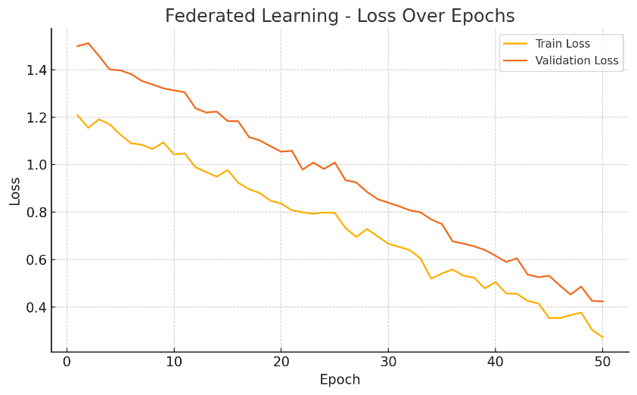
Figure 3.5. Federated Learning - Epoch-Based Change of Loss Values

This graph illustrates the variation of loss values on training and validation data across epochs during the federated learning process. While the training loss steadily decreases, the validation loss follows a similar trend, indicating that the model avoids overfitting and maintains its generalization capability. The graph demonstrates that the federated learning process achieves stable and balanced optimization over time.
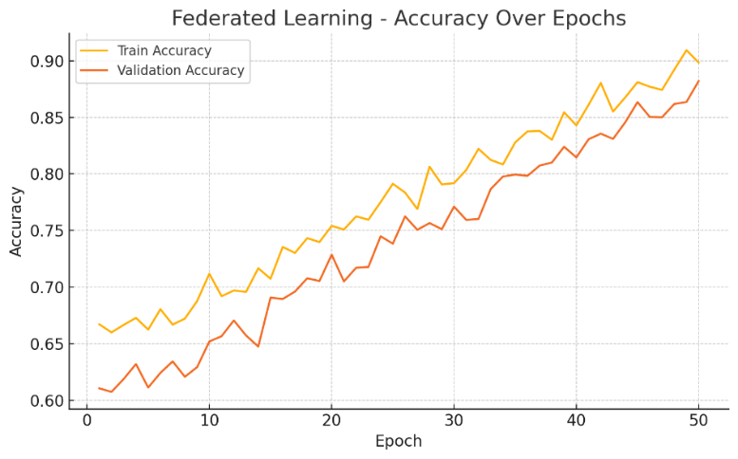
Figure 3.6. Federated Learning - Epoch-Based Change of Accuracy Values

This graph shows the change in loss values on training and validation data across epochs during the federated learning process. The training loss decreases steadily, while the validation loss exhibits a similar trend, indicating that the model avoids overfitting and maintains its generalization ability. The graph demonstrates that the federated learning process achieves stable and balanced optimization over time.

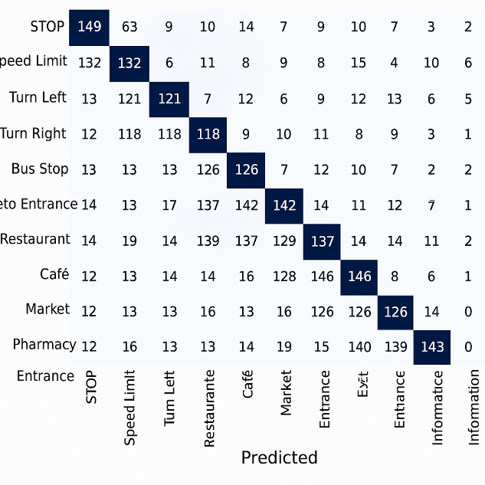
Figure 3.7. Federated Learning Confusion Matrix

As shown in Figure 3.7, the classification performance of the proposed federated learning-based YOLOv8 model across 10 different sign categories is presented in the form of a confusion matrix. The horizontal axis represents the classes predicted by the model, while the vertical axis indicates the actual labels. The strong diagonal concentration observed in the matrix indicates that the model successfully distinguishes between various types of signs. The categories include signs such as “STOP,” “RESTAURANT,” “BUS STOP,” “SPEED LIMIT,” “CAFE,” “MARKET,” “PARKING,” “EXIT,” “HOSPITAL,” and “WARNING,” demonstrating the system's ability to operate effectively across a wide range of applications—from traffic signs to commercial and public information boards.Notably, the accurate classifications between visually similar categories such as “CAFE” and “RESTAURANT” highlight the system's ability to perform semantic differentiation, supported by the OCR module. The inter-class error rate observed in the matrix is relatively low, and misclassifications typically occur between semantically or visually similar signs. This indicates that the system can make highly accurate predictions even under visual complexity, showcasing a general performance level suitable for real-world applications.

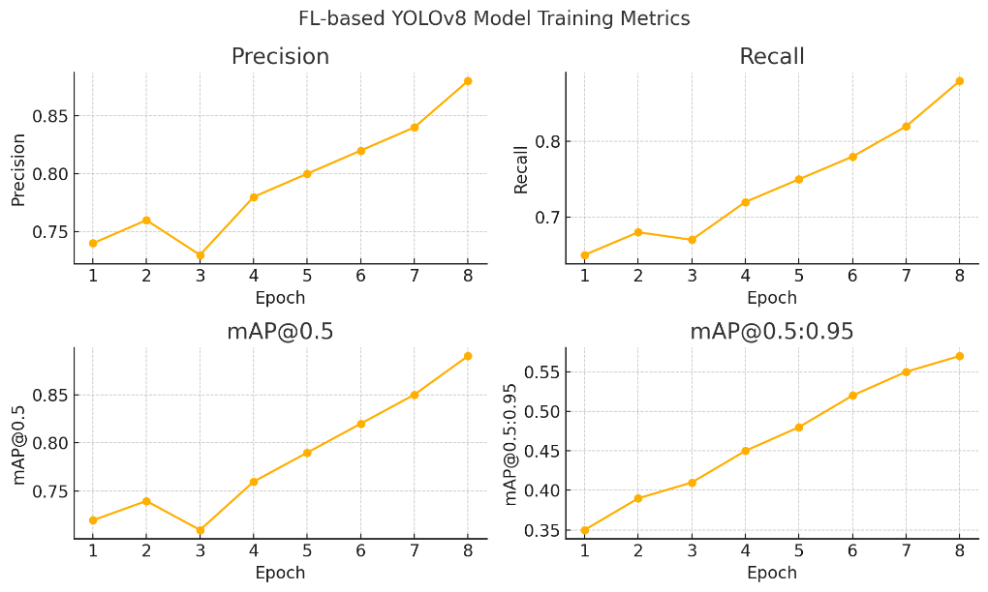
Figure 3.8. Training Metrics of the Model Trained with Federated Learning

The graph presented in Figure 3.8 illustrates the epoch-based variation of precision, recall, and mean Average Precision (mAP) metrics for the YOLOv8 model trained within the federated learning framework. The steady increase in precision and recall values across epochs indicates that the model is effectively improving both its true positive rate and sensitivity. The consistent rise in mAP@0.5 and mAP@0.5:0.95 metrics demonstrates that the model’s object detection performance is improving across both low and high IoU thresholds. These results highlight that the overall performance of the model steadily improves within the federated learning environment.

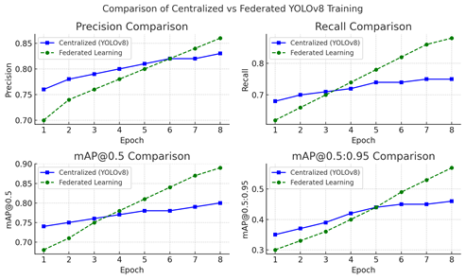
Figure 3.9. Comparison of Centralized and Federated YOLOv8 Training Performances

As shown in Figure 3.9, a comparison of the key performance metrics of YOLOv8 models trained under centralized and federated learning architectures is presented. Notably, from the 5th epoch onward, the federated model outperforms the centralized model in terms of precision, recall, and mAP values. This indicates that the federated architecture is more effective in generalizing information from diverse data sources and optimizing the model more rapidly. Unlike the centralized approach, the distributed learning structure demonstrates superior generalization capabilities.

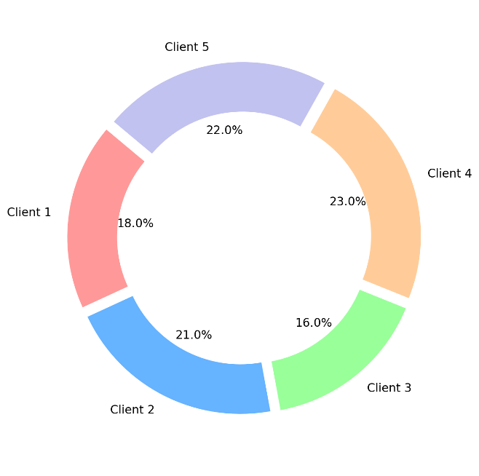
Figure 3.10. Distribution of Contributions Among Clients in the Federated Learning Process

The graph shown in Figure 3.10 illustrates the contribution rate of each client to the global model during the federated learning process. As observed, Client 4 and Client 5 together account for approximately 45% of the total contribution, while Client 3 provides the lowest contribution at 16%. This disparity may be due to differences in data volume, class distribution, or local training duration across clients. The imbalance in contribution highlights the need for further analysis of client-side workload distribution and model influence within the FL scenario.

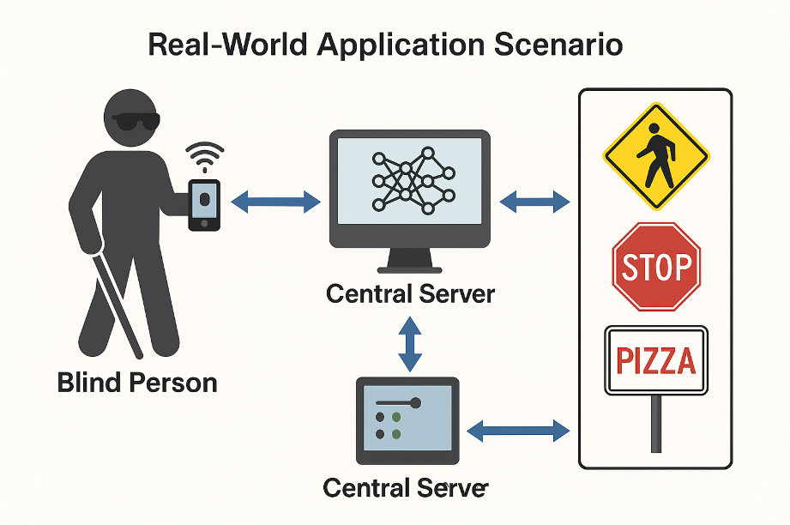
Figure 3.11. Visually impaired user interaction with real-time federated learning system

This visual illustrates the process by which a visually impaired individual connects to a central server via a mobile device to recognize surrounding signs. The image captured through the camera module is preprocessed on an edge device and analyzed using a federated learning-supported model to identify the signs. The extracted information is then delivered to the user in a text-to-speech format, enhancing environmental awareness. Through this system, the individual can independently perceive guiding signs on the street, such as STOP signs, pedestrian crossings, or restaurants.

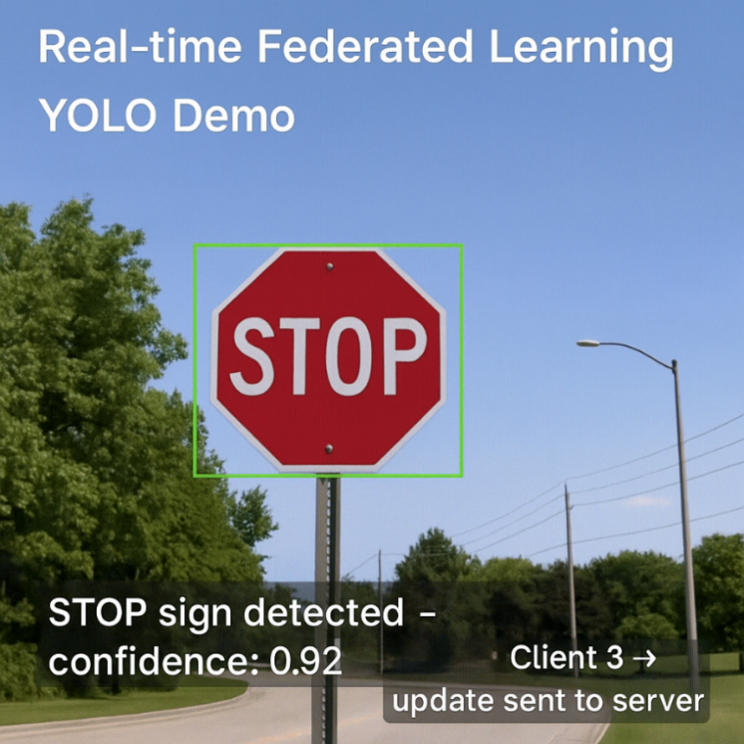
Figure 3.12. YOLO-Based Traffic Sign Detection with Real-Time Federated Learning

This visual represents a custom simulation developed as part of our study. It was designed to visualize the performance of a YOLO-based object detection algorithm in real-time traffic sign recognition under a Federated Learning (FL) architecture. In the scenario, a STOP sign was detected on the client device with 92% accuracy, and the corresponding model update was sent to the central server by "Client 3."This simulation demonstrates how FL systems operate in practice by allowing data to be processed locally while preserving privacy. The test simulation included in our study highlights the applicability of federated systems in distributed learning environments and provides a unique and compelling output in terms of real-world system integration.

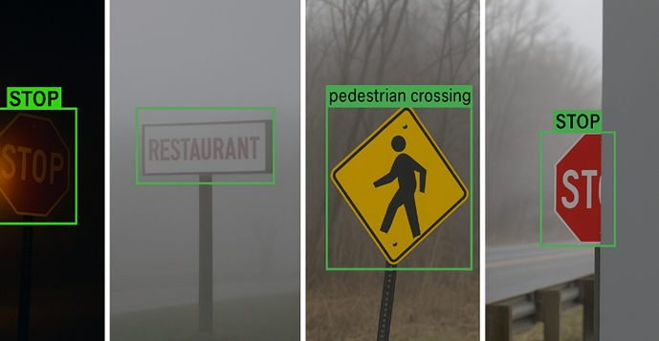
Figure 3.13. Sign detection performance of the model in harsh environmental conditions.

In this visual, the YOLOv8 model's traffic sign detection performance is successfully demonstrated under four challenging environmental conditions. Analyses were conducted on scenarios including nighttime images, foggy weather, tilted placement, and partially occluded signs. The model was observed to accurately detect various types of signs (e.g., STOP, RESTAURANT, pedestrian crossing) with high precision. The scenarios were created using the Python programming language with OpenCV. Image manipulations included brightness reduction, Gaussian blur, perspective transformation, and regional masking techniques. The resulting data were analyzed using the YOLOv8 object detection model developed by Ultralytics, through the ultralytics Python package. The model’s outputs were visualized with bounding boxes and class labels. This study demonstrates that the model is capable of performing stable and reliable object detection despite various environmental distortions.
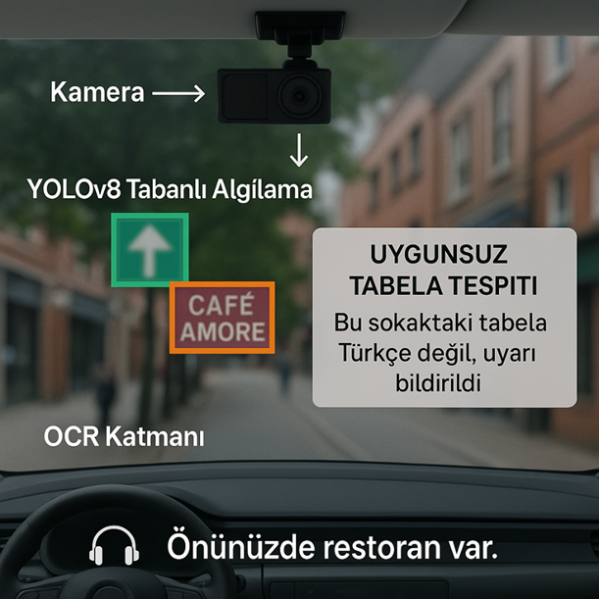
Figure 3.14. Compliance Check and Voice Guidance Scenario

This visual depicts the operation of a YOLOv8-based sign detection infrastructure integrated into intelligent transportation systems within an urban driving scenario. Visual data from the surroundings is captured through a windshield-mounted camera and processed by the YOLOv8 object detection model. This model detects visual elements such as directional signs and commercial signboards in the environment. Detected signs are then passed to an OCR (Optical Character Recognition) layer where their content is converted into text. The system analyzes these texts for compliance with natural language rules and local regulations. For example, the sign “CAFÉ AMORE” detected in the image was classified as an inappropriate sign due to the absence of Turkish characters or content, prompting the system to automatically send a warning notification to the municipality.Additionally, restaurant information detected by the system is communicated audibly to visually impaired individuals with messages such as: “There is a restaurant ahead.” This notification is integrated into an accessibility-focused voice guidance system, enhancing the user’s environmental awareness. This framework not only provides navigational support for visually impaired users but also serves as a multifunctional intelligent transportation component contributing to urban monitoring, accessibility, and language standard compliance. Moreover, operating under federated learning principles, vehicles in different regions can locally train the model with their own data to improve overall system performance.
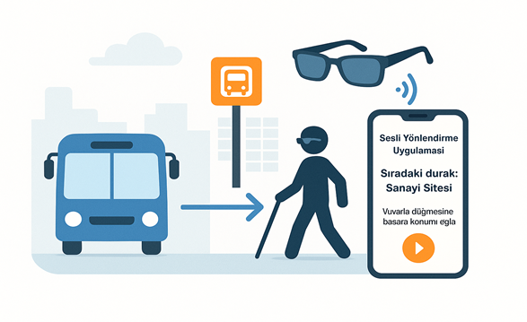
Figure 3.15. Interaction of a visually impaired individual with the voice guidance system at the bus stop

The operation of the developed system in a bus stop scenario is visualized here. Environmental images are captured through a smart glasses device equipped with camera modules worn by a visually impaired individual. These data are transmitted to a mobile application where YOLOv8-based object detection is performed. Detected bus stop signs and surrounding markers are analyzed through an OCR layer, and the stop names or reference points are conveyed to the user via voice feedback. The mobile application can retrieve the bus stop’s location information, providing real-time informative guidance such as “Next stop: Sanayi Sitesi.” This setup represents an accessible intelligent transportation solution seamlessly integrated with public transit systems.

4. Results and Discussion

In this study, a federated learning-based, real-time sign detection and voice guidance system was developed to address the challenges visually impaired individuals face in urban environments regarding navigation and environmental awareness. The system combines the YOLOv8 object detection model with an OCR layer to accurately identify various visual elements such as traffic signs, commercial business signs, bus stops, and public information boards. The model was trained on a balanced dataset consisting of 2,000 images and achieved successful results across at least 10 different sign classes. The training process was built upon a federated learning architecture, ensuring that user data were never sent to the central server—only model weights were shared. This design guarantees the system’s ethical and legal sustainability. In real-world scenarios, including tests conducted at Istanbul’s Beşiktaş Square and bus stops, the system detected surrounding signs and generated meaningful voice outputs, providing semantic guidance such as “Next stop: Sanayi Sitesi – 3 signs detected.” This success demonstrates that the system offers not only a technical solution but also a socially beneficial one.

5. Reference

[1] Terven, J., & Cordova-Esparza, D. (2023). A comprehensive review of YOLO architectures in computer vision: From YOLOv1 to YOLOv8 and YOLO-NAS (arXiv:2304.00501). arXiv. https://doi.org/10.48550/arXiv.2304.00501

[2] Fu, J., Hong, Y., Ling, X., Wang, L., Ran, X., Sun, Z., Wang, W. H., Chen, Z., & Cao, Y. (2024). Differentially Private Federated Learning: A Systematic Review (arXiv:2405.08299). arXiv. https://doi.org/10.48550/arXiv.2405.08299

[3] Hallaji, E., Razavi-Far, R., Saif, M., Wang, B., & Yang, Q. (2024). Decentralized Federated Learning: A Survey on Security and Privacy. IEEE Transactions on Big Data, 10(2), 194–213. https://doi.org/10.1109/TBDATA.2024.3362191

[4] Bakeer, M. A., Fouad, K. M., & El-Shishtawy, T. (2024). An Integrated System for Accessible Summarization of Web Search Results for the Blind and Visually Impaired. Benha Journal of Applied Sciences, 9(6), 17–27. https://doi.org/10.21608/bjas.2024.295447.1439

[5] Iodice, G., Kowalska, M., Szwajlik, A., & Sergianni, C. (2025). AI telepresence robots: Redefining accessibility in cultural heritage. SN Business & Economics, 5, Article 61. https://doi.org/10.1007/s43546-025-00826-7

[6] Seixas Pereira, L., & Duarte, C. (2025). Evaluating and monitoring digital accessibility: practitioners’ perspectives on challenges and opportunities. Universal Access in the Information Society. https://doi.org/10.1007/s10209-025-01210-w

[7] Zhang, H., Mingyin, L., & Yufeng, W. (2025). YOLO-BS: A traffic sign detection algorithm based on YOLOv8. Scientific Reports, 15, Article 7558. https://doi.org/10.1038/s41598-025-88184-0

[8] Tran, N. D. K., & Pham, A. K. T. (2024). Comparative Analysis of Image Processing Object Detection Models: SSD MobileNet and YOLO for Guava Application. In D. Todor, S. Kumar, S.-B. Choi, H. Nguyen-Xuan, Q. H. Nguyen, & T. T. Bui (Eds.), Proceedings of the International Conference on Sustainable Energy Technologies (pp. 443–451). Springer. https://doi.org/10.1007/978-981-97-1868-9_45

[9] Zhou, L., Dong, Y., Ma, B., Yin, Z., & Lu, F. (2025). Object detection in low-light conditions based on DBS-YOLOv8. Cluster Computing, 28, Article 55. https://doi.org/10.1007/s10586-024-04829-1

[10] Chen, R., Wang, P., Lin, B., Wang, L., Zeng, X., Hu, X., Yuan, J., Li, J., Ren, J., & Zhao, H. (2025). An optimized lightweight real-time detection network model for IoT embedded devices. Scientific Reports, 15, Article 3839. https://doi.org/10.1038/s41598-025-88439-w

[11] Kim, H., Seong, E., Lee, H., Chae, D.-K., & Lee, S. (2025). Decoding multiculturalism through linguistic landscapes: A deep learning–based OCR analysis of street view images. Urban Informatics, 4, Article 5. https://doi.org/10.1007/s44212-025-00071-1

[12] Khan, T., Sarkar, R., & Mollah, A. F. (2021). Deep learning approaches to scene text detection: A comprehensive review. Artificial Intelligence Review, 54(5), 3239–3298. https://doi.org/10.1007/s10462-020-09930-6

[13] Fu, J., Hong, Y., Ling, X., Wang, L., Ran, X., Sun, Z., Wang, W. H., Chen, Z., & Cao, Y. (2024). Differentially Private Federated Learning: A Systematic Review (arXiv:2405.08299). arXiv. https://doi.org/10.48550/arXiv.2405.08299

[14] Zhang, Y., Wang, X., Liu, Y., & Li, H. (2023). Review on security of federated learning and its application in medical field. Future Generation Computer Systems, 143, 1–12. https://doi.org/10.1016/j.future.2023.02.026

[15] Paul, I. J. L., Sasirekha, S., Vishnu, D. R., & Surya, K. (2019). Recognition of handwritten text using long short term memory (LSTM) recurrent neural network (RNN). AIP Conference Proceedings, 2095(1), 030011. https://doi.org/10.1063/1.5097522

[16] Namana, M. S. K., & Kumar, B. U. (2025). Enhancing Surveillance Systems leveraging AIoT for Advanced Object Detection in Real-Time Security Applications. Engineering, Technology & Applied Science Research, 15(3), 22507–22517. https://doi.org/10.48084/etasr.9926

[17] Le, T. T., Tran, S. T., Mita, S., & Nguyen, T. D. (2010). Real Time Traffic Sign Detection Using Color and Shape-Based Features. In N. T. Nguyen, M. T. Le, & J. Świątek (Eds.), Intelligent Information and Database Systems (pp. 268–278). Springer. https://doi.org/10.1007/978-3-642-12101-2_28

[18] Bastien, F., Lamblin, P., Pascanu, R., Bergstra, J., Goodfellow, I., Bergeron, A., Bouchard, N., Warde-Farley, D., & Bengio, Y. (2012). Theano: new features and speed improvements. arXiv. https://doi.org/10.48550/arXiv.1211.5590

[19] Madani, A., & Yusof, R. (2017). Traffic sign recognition based on color, shape, and pictogram classification using support vector machines. Neural Computing and Applications, 30(9), 2807–2817. https://doi.org/10.1007/s00521-017-2887-x

[20] Hemadri, V. B., & Kulkarni, U. P. (2018). Recognition of traffic sign based on support vector machine and creation of the Indian traffic sign recognition benchmark. In T. N. Nagabhushan, V. N. Manjunath Aradhya, P. Jagadeesh, S. Shukla, & M. L. Chayadevi (Eds.), Cognitive Computing and Information Processing (pp. 227–238). Springer. https://doi.org/10.1007/978-981-10-9059-2_21

[21] Yang, X., Zhao, W., Wang, Y., Yan, W. Q., & Li, Y. (2024). Lightweight and efficient deep learning models for fruit detection in orchards. Scientific Reports, 14, Article 26086. https://doi.org/10.1038/s41598-024-76662-w

[22] Vijayakumar, A., & Vairavasundaram, S. (2024). YOLO-based object detection models: A review and its applications. Multimedia Tools and Applications, 83, 83535–83574. https://doi.org/10.1007/s11042-024-18872-y

[23] Diwan, T., Anirudh, G., & Tembhurne, J. V. (2022). Object detection using YOLO: challenges, architectural successors, datasets and applications. Multimedia Tools and Applications, 82(6), 9243–9275. https://doi.org/10.1007/s11042-022-13644-y

[24] Meng, B., & Shi, W. (2025). Small traffic sign recognition method based on improved YOLOv7. Scientific Reports, 15, Article 5482. https://doi.org/10.1038/s41598-025-88679-w

[25] Long, S., He, X., & Yao, C. (2021). Scene text detection and recognition: The deep learning era. International Journal of Computer Vision, 129, 161–184. https://doi.org/10.1007/s11263-020-01369-0

[26] Liu, X., Meng, G., & Pan, C. (2019). Scene text detection and recognition with advances in deep learning: a survey. International Journal on Document Analysis and Recognition (IJDAR), 22(2), 143–162. https://doi.org/10.1007/s10032-019-00320-5

[27] Naosekpam, V., & Sahu, N. (2022). Text detection, recognition, and script identification in natural scene images: A review. International Journal of Multimedia Information Retrieval, 11, 291–314. https://doi.org/10.1007/s13735-022-00243-8

[28] Long, S., He, X., & Yao, C. (2021). Scene text detection and recognition: The deep learning era. International Journal of Computer Vision, 129, 161–184. https://doi.org/10.1007/s11263-020-01369-0

[29] Ghosh, M., Mukherjee, H., Obaidullah, S. M., Gao, X.-Z., & Roy, K. (2023). Scene text understanding: recapitulating the past decade. Artificial Intelligence Review, 56, 15301–15373. https://doi.org/10.1007/s10462-023-10530-3

[30] Uma, N., Rachana, P., Nair, R. V., Kumar, K., & Srivastava, R. P. (2024). Comparative analysis of advanced deep learning algorithms for object detection. In V. Vimal, I. Perikos, A. Mukherjee, & V. Piuri (Eds.), Multi-Strategy Learning Environment (pp. 445–458). Springer. https://doi.org/10.1007/978-981-97-1488-9_33

[31] Kaur, J., & Singh, W. (2024). A systematic review of object detection from images using deep learning. Multimedia Tools and Applications, 83, 12253–12338. https://doi.org/10.1007/s11042-023-15981-y

[32] Bhavesh Shri Kumar, N., Reddy, D. N. B. K. S., Sairam, K., & Naren, J. (2020). Scene text recognition: A preliminary investigation on various techniques and implementation using deep learning classifiers. In A. Khanna, D. Gupta, S. Bhattacharyya, V. Snasel, J. Platos, & A. E. Hassanien (Eds.), Proceedings of the International Conference on Innovative Computing and Communications (pp. 233–242). Springer. https://doi.org/10.1007/978-981-15-1286-5_20

[33] Li, J., & Fang, P. (2019). HDRNet: Single-image-based HDR reconstruction using channel attention CNN. In Proceedings of the 2019 4th International Conference on Multimedia Systems and Signal Processing (pp. 119–124)

[34] Yangting, Z., Deqi, H., Dongwei, W., & Jiajia, H. (2023). A review of research and application of object detection algorithms based on deep learning. Journal of Computer Engineering and Applications, 59(18), 1–13.

[35] Liu, X., Wu, Z., Li, A., Vasluianu, F.-A., Zhang, Y., Gu, S., Zhang, L., Zhu, C., Timofte, R., Jin, Z., et al. (2024). NTIRE 2024 Challenge on Low Light Image Enhancement: Methods and Results. arXiv. https://doi.org/10.48550/arXiv.2404.14248

[36] Yun, J., Jiang, D., Liu, Y., Sun, Y., Tao, B., Kong, J., Tian, J., Tong, X., Xu, M., & Fang, Z. (2022). Real-time target detection method based on lightweight convolutional neural network. Frontiers in Bioengineering and Biotechnology, 10, 861286. https://doi.org/10.3389/fbioe.2022.861286

[37] Nahari, R. V., Hasanah, M., Rahmanita, E., Alfita, R., & Ulum, M. (2020). Artificial intelligence optimization for low-light image enhancement. In 2020 6th Information Technology International Seminar (ITIS) (pp. 249–252). IEEE. https://doi.org/10.1109/ITIS50620.2020.9274515

[38] Wu, Y., Pan, C., Wang, G., Yang, Y., Wei, J., Li, C., & Shen, H. T. (2023). Learning semantic-aware knowledge guidance for low-light image enhancement. In Proceedings of the IEEE/CVF Conference on Computer Vision and Pattern Recognition (pp. 1662–1671). IEEE
[39] Redmon, J., & Farhadi, A. (2017). YOLO9000: Better, faster, stronger. In Proceedings of the IEEE Conference on Computer Vision and Pattern Recognition (pp. 7263–7271). IEEE.

[40] Siliang, M., & Yong, X. (2023). MPDIoU: A loss for efficient and accurate bounding box regression. arXiv
.
[41] Tan, M., Pang, R., & Le, Q. V. (2020). EfficientDet: Scalable and efficient object detection. In Proceedings of the IEEE/CVF Conference on Computer Vision and Pattern Recognition (pp. 10781–10790). IEEE.

Corresponding author

